Servlet Pagination Screenshots

Home Page:  
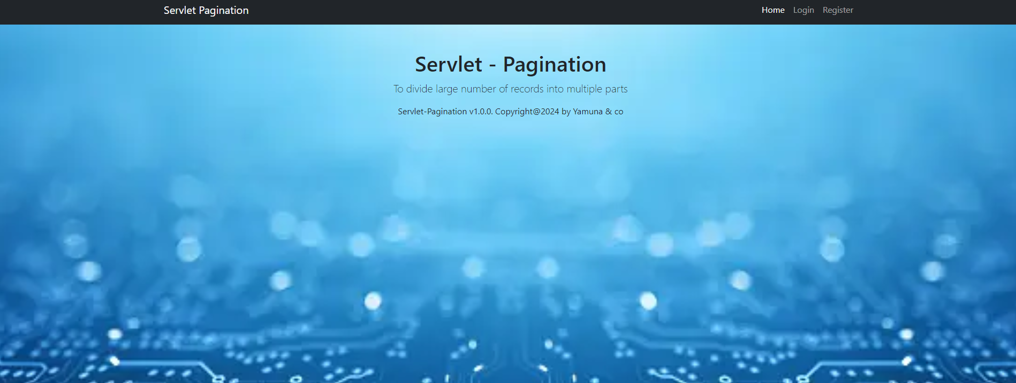

Login Page:

Login Register Page:

Main Page:

Student Register Page:

Student edit page:  
